On November 9th 2024 the Haaksbergen Open Karate Championship is taking place in Haaksbergen.

**Organisation**

IBF Nederland

Contact information: Wendy Schierboom; phone: 0031 6 11 45 96 53; email: wschierboom@ibfnederland.onmicrosoft.com

**Voor who**

The championship is open to everyone. Individual IBF members pay a lower fee then individuals who are not a member.

**Date**

November 9th 2024

**Location**

Sporthal De Els

Trompstraat 20

7482 VX Haaksbergen

**Starting time**

**Forms:** 9.30

**Fights:** weighing: 10.30 start:11.30

**Age**

**Forms**

**Youth: boys** 6 - 10 years**; girls** 6 - 10 years

**Juniors: boys** 11 - 15 years; **girls** 11 - 15 years

**Seniors: men** 16 years and older**; women** 16 years and older

**Veterans:** 45 years and older

**Fights**

**Youth** 6 -10 years; **juniors** 11 - 15 years, **seniors** 16 years and older and **veterans** 45 years and older

**Fights weight classes**

Youth 6 - 10 years: -25, -30, -35, -40, -45, +45

Juniors 11 - 15 years: -30, -35, -40, -45, -50, -55, -65, +65

Seniors 16 years and older women: -55, -65, -75, +75 men: -60, -65, -70, -75, -80, -90, +90

Seniors team fights women: -65, -75, 75+

men: -65, -70, -75, -80, 80+

Veterans 45 years and older women: all weights

men: all weights

When there are to few registration in a weight class, weight classes will be put together. When there are to few registrations in the veteran poules, the veterans will be added to the seniors poules. When there are not enough team registrations, the team poules will be cancelled.

**Prices**

1st, 2th and 3th price in each category.

**System fights**

K.O. system.

**Competition regulation**

IBF semi-regulation (https://ibf-international.org/download-2/).

**Costs**

|  |  |  |
| --- | --- | --- |
|  | Costs IBF members | Costs non-members |
| Kata youth/juniors (until 15 years) | € 12,50 | € 20 |
| Kata seniors (16 years and older) | € 17,50 | € 25 |
| Kata veterans (45 years and older) | € 17,50 | € 25 |
| Weapon-kata youth/juniors (until 15 years) | € 12,50 | € 20 |
| Weapon-kata seniors (16 years and older) | € 17,50 | € 25 |
| Team kata | € 10 per person | € 15 per person |
| Fights youth/juniors (until 15 years) | € 12,50 | € 20 |
| Fights seniors (16 years and older) | € 17,50 | € 25 |
| Fights veterans (45 years and older) | € 17,50 | € 25 |
| Team fights women | € 10 per person | € 15 per person |
| Team fights men | € 10 per person | € 15 per person |

**Payments**

The registration fee has to be paid before Oktober 26th 2024 to account number: NL12 SNSB 8845 3782 41, account name: PM Brugge, description: Haaksbergen Open 2024, club name and number of registrations.

**Outfit fights**

* Karatesuite (no roled up sleeves and pipes, no t-shirts for men)
* A **cup** is obligated for everyone.
* **Boxing gloves** The thumb has to be attached to the rest of the glove. The glove has to be completely closed. Untill 10 years 8 ounce (10 ounce is also permitted); 11 years and older **10 ounce**
* **Foot protection**, They have to cover the enter feet. The toenails have to be cut short.

Sports Hijabs are allowed.

All protection has to be made out of soft materials. Hard plastic, knots, zippers etcetera are not allowed.

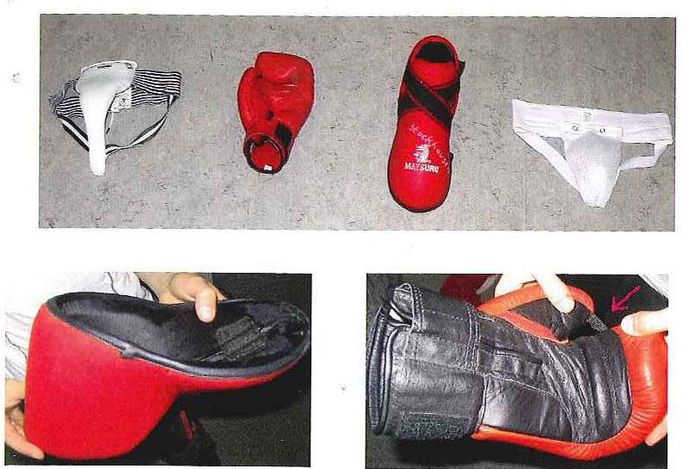

**Registration** before Oktober 26th 2024 via email (wschierboom@ibfnederland.onmicrosoft.com). The attached registration form has to be used. Other forms of registration will not be accepted. Only one registration form per club is allowed.

**Free entrance for spectators!**

**Participation is at own risk!**